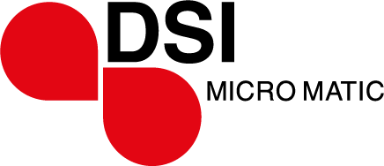

EU´s 11th sanctions package towards Russia

Dear valued supplier,

With EU´s implementation of 11th sanction package towards Russia, which includes an update of documentation of imported goods, in which iron and steel is used, we kindly ask you to confirm, using the form of this letter, that your company does not use any iron or steel of Russian origin, and confirm that your company at any given time can provide documentation including, but not limited to, Mill Test Certificates for the material used in products ordered by DSI Micro Matic.

Mill Test Certificates (MTC) must include the following:

* Name of producer
* Country of production
* Origin of component / materials
* HS-code

# Compliance

DSI Micro Matic expects that its suppliers are in compliance with the aforementioned implementation and prepared to sign the following declaration.

# Confirmation

We confirm that do not use any materials with Russian origin for the products delivered to DSI Micro Matic and that at any given time we can provide documentation including, but not limited to, Mill Test Certificates for the material used in products ordered by DSI Micro Matic, in accordance to EU´s sanctions.

Date: Signature:

VT-009A *Page* ***1*** *of* ***1***